Code for Scalar Vector Addition

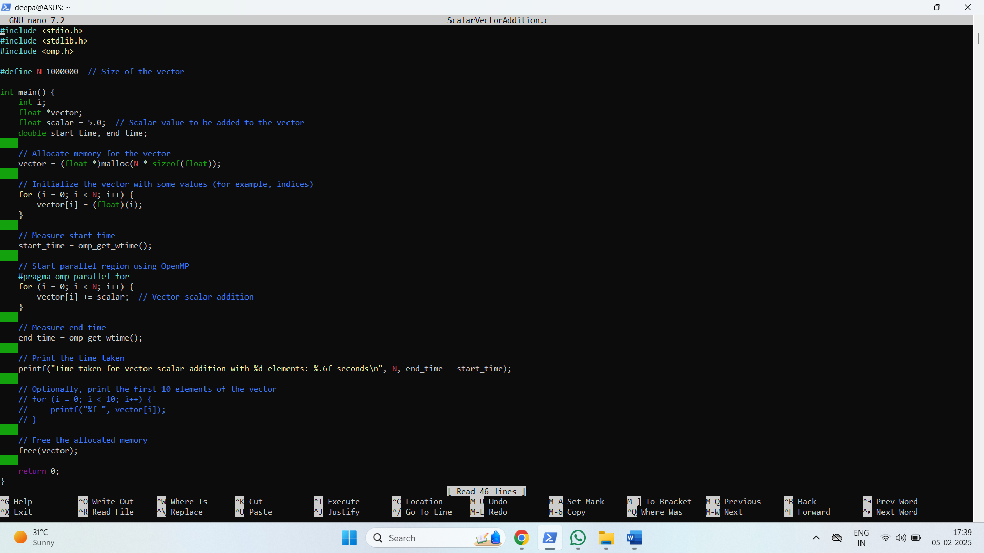

Output

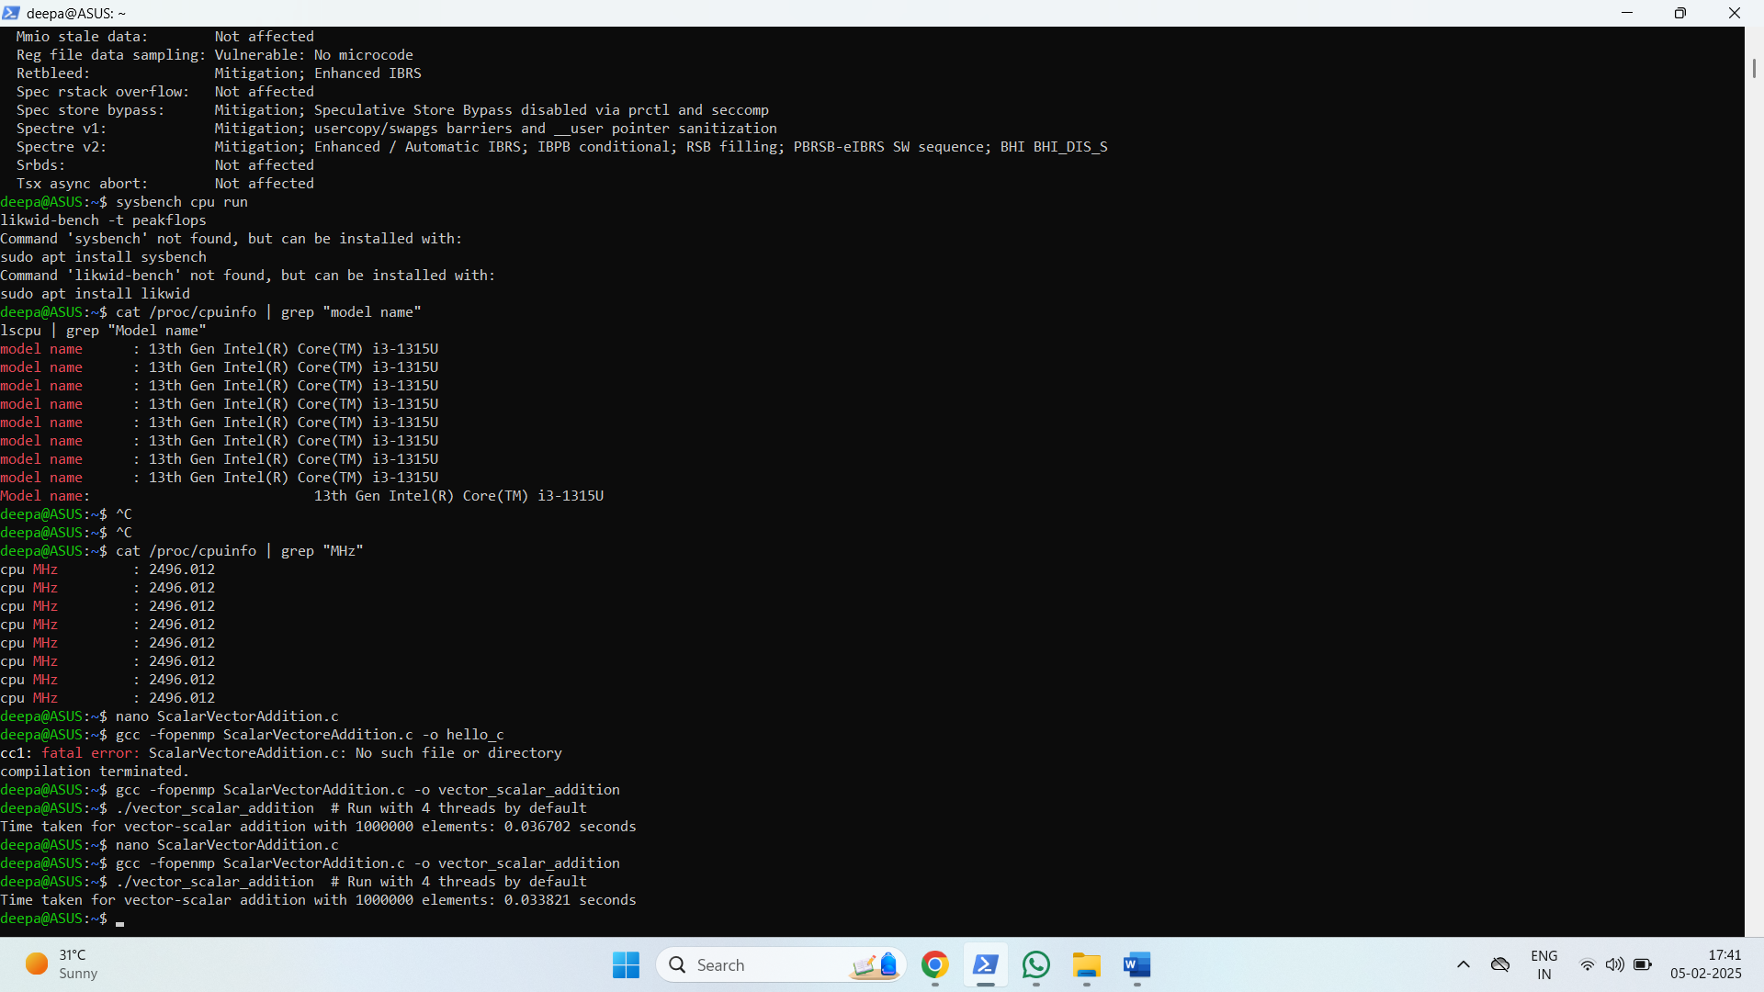

**Information**:

1. We initialize a vector of size N, where each element is initialized to the index value.

2. The program adds a scalar (value 5.0) to each element in the vector in parallel using OpenMP's #pragma omp parallel for directive.

3. We use omp_get_wtime() to measure the execution time of the parallelized vector-scalar addition

Code for Calculation of value of pi

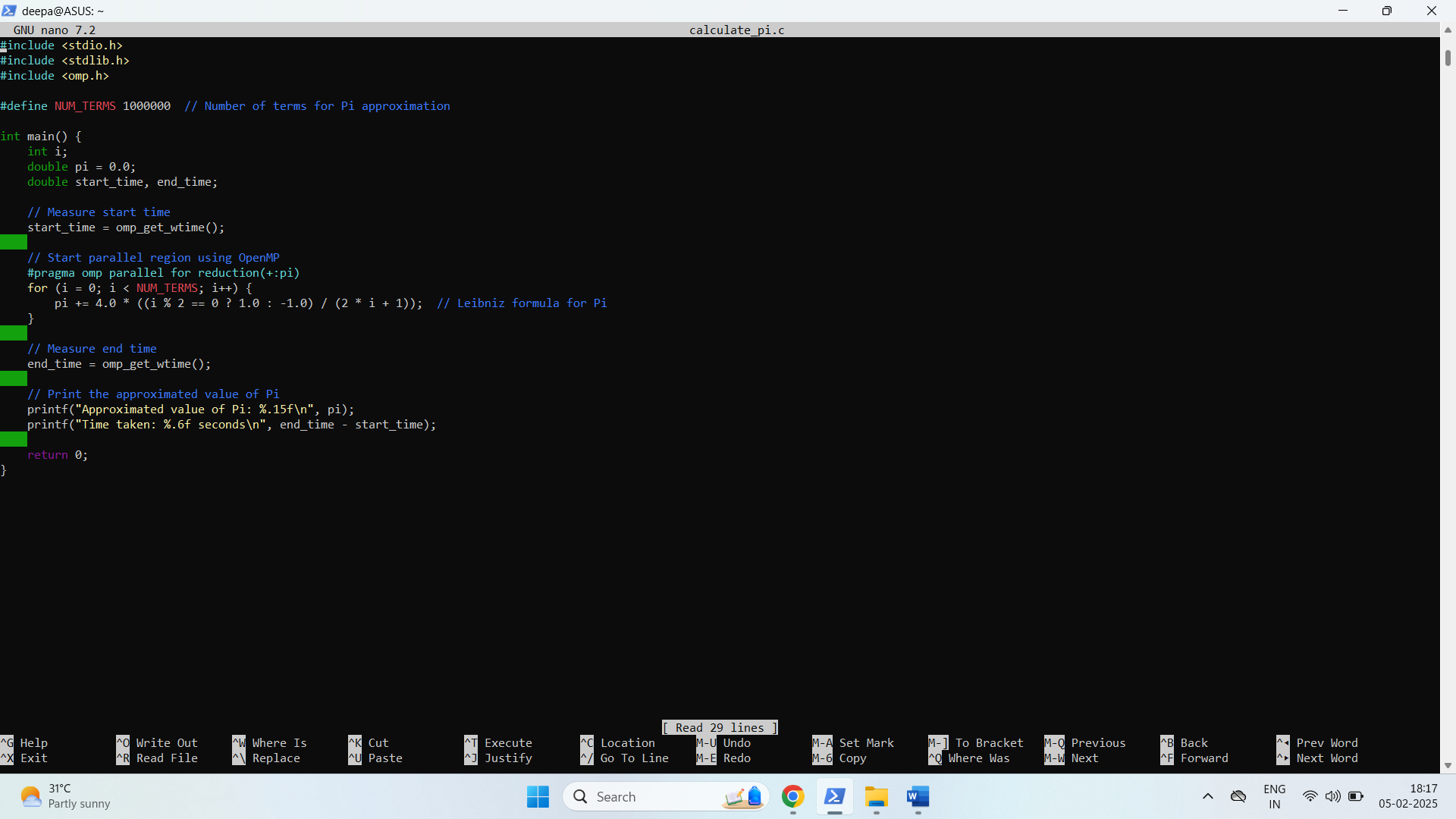

Output:

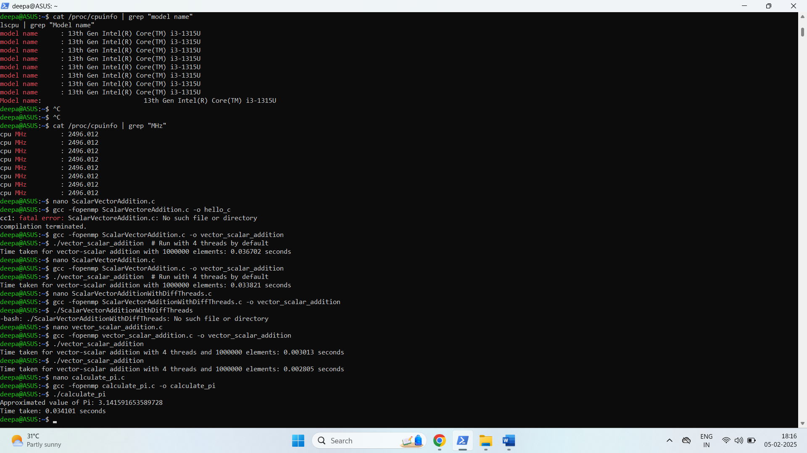

**Information**:

1.**OpenMP Parallelization:**

* We use #pragma omp parallel for reduction(+:pi) to parallelize the loop and accumulate the sum in a thread-safe way.
* The reduction(+:pi) ensures that each thread gets its private copy of the pi variable and only the final sum is shared and accumulated.

2.**Timing:** omp_get_wtime() is used to measure the execution time of the program.

GITHUB Link: